Decision Tree Regression Intution

CART

Classification Trees and Regression Trees

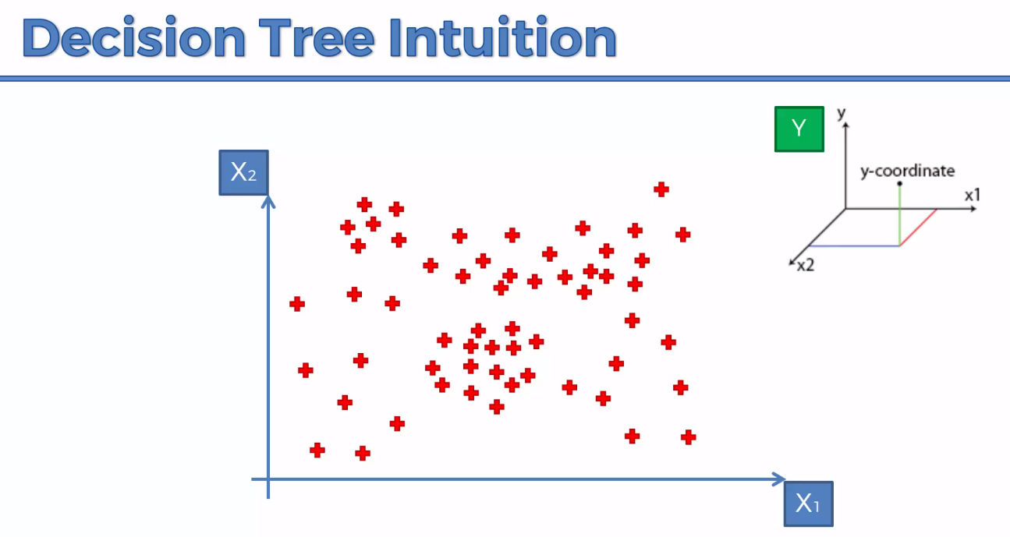Dependent 2 X variable and Y is in the Z direction

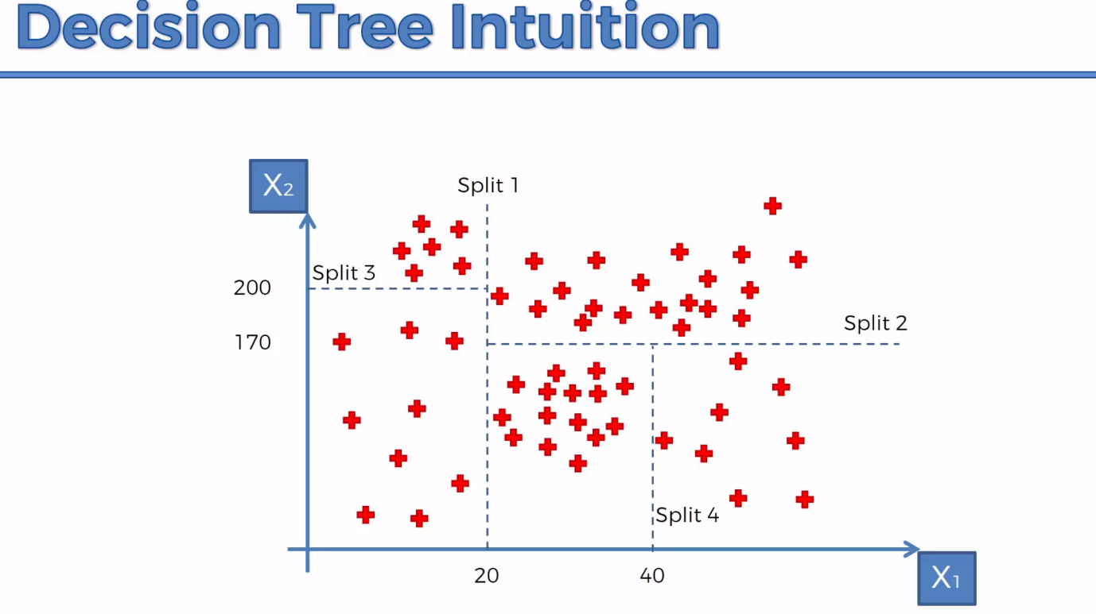Need to split the dataset into 4 charts. Information Entropy.

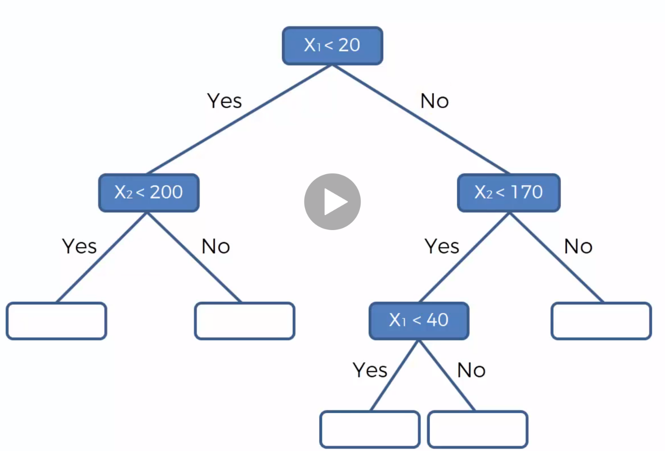Terminal Leaves. Are the Splits   
Predict the value of Y after you split by averaging all the points in individual leaves

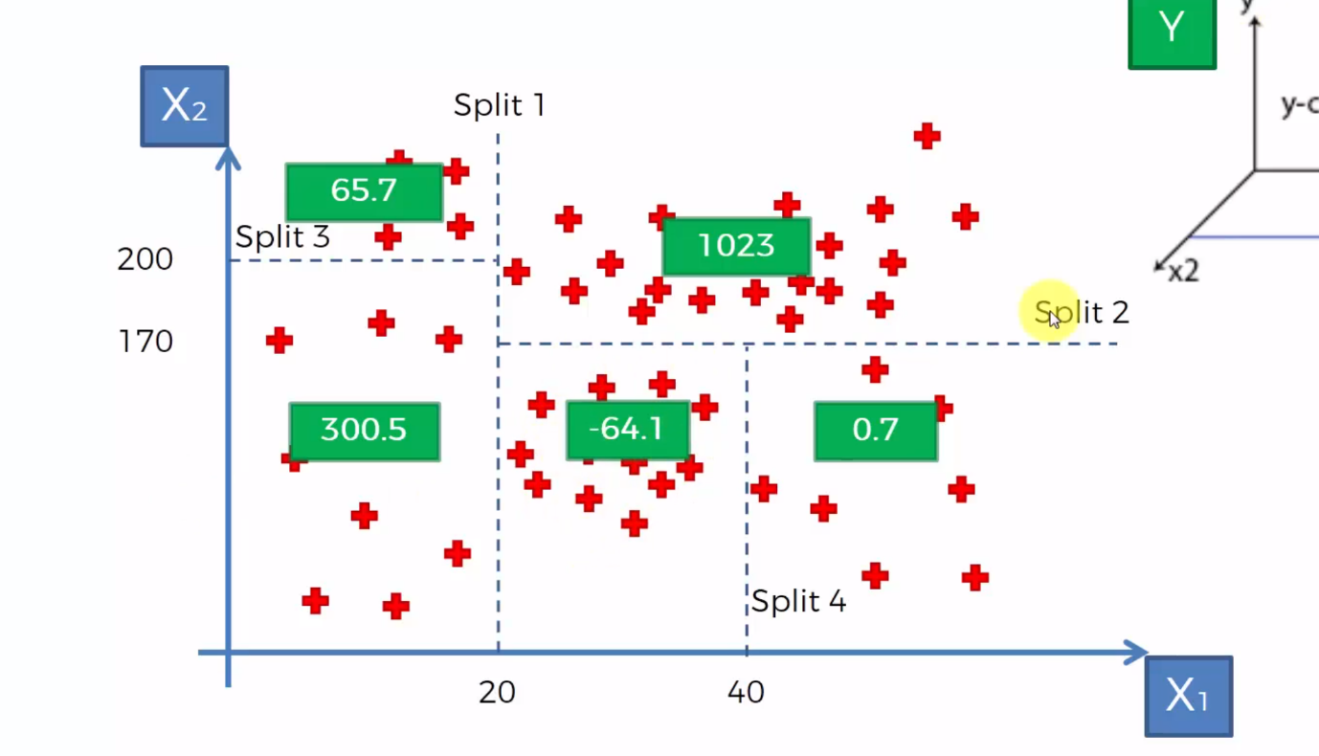

Therefore Final Decision Tree looks like this

